OnGoing Project Instructions

2 CATEGORIES FOR ONGOING SERVICE OPPORTUNITIES FOR THE CARING CLOSET

Category One: Bags 4 Kids

- Encouraging Card Project - Service Hours: 3

Description: Please create fun encouraging cards to be placed in care bags that the Caring Closet gives to children experiencing crisis. Please make 20 encouraging cards. Use your favorite quotes and a personal message and decorate the card. If you would like to make more than 20 cards, feel free to do so.

Ideas: One way to do this would be to create five cards with an encouraging quote and a personal message then do those over again four times. You are welcome to use card stock or scrapbooking paper or other creative ideas to make your cards. Please make it look neat, colorful and fun.

Sample card ideas below:

e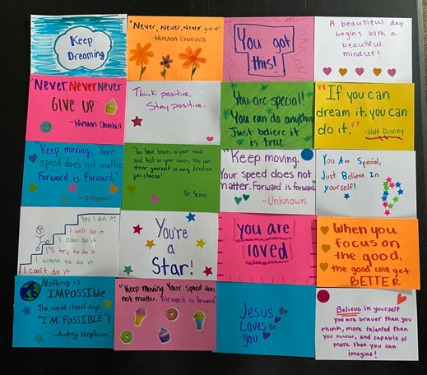
- Origami Kit Project - Service Hours: 3

Description: Please make fun origami kits to be placed in care bags and holiday bags that are distributed to children in crisis in the Richmond area. Please make 15 to 20 kits…or more if you would like.

Each kit should contain:

- 20 assorted sheets of origami paper;

- Add three easy patterns per kit. Fold neatly to fit in bag. If you need ideas try www.origami-fun.com.

- Place all in quart-sized zip-lock bag;

- Make an encouraging and festive note card for each kit on 3 X 5 notecard or other fun paper. Example: “You are awesome!”, “You Rock!”, “Be Happy!”.

- Write “Origami” on a white label and decorate it;

- Place decorated label on kit, or if you don’t have a label, please use a Sharpie or to write “Origami” on the bag.

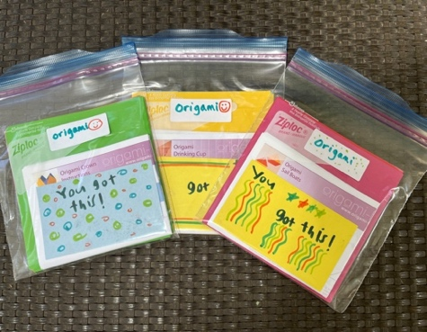

- Shopping Kit Projects – 3 Service Hours for each category

Note: - If you would like to make more than one kit in the same category, you will receive 1 additional
service hour per extra kit. For example: Two dental kits would be 4 hours (3 for 1st kit & 1 for
2nd kit).
-If you organize a collection, please keep track of your hours.

Description: Please shop (or organize a collection) for the items listed in each kit. Please make five (5) encouraging cards using your favorite quotes for each shopping project.

Comfort Item Kit | * 1 or more 50x60 lightweight fleece blankets (click this for a similar product).  * 1 or more beanie baby-sized stuffed animals. NO baby  or toddler themes as “friends” also go to teens.  * 1 or more soft squishy stress ball or a small squeezy  fidget toy  * Make 5 encouraging cards using your favorite quotes  and decorate the cards.
Dental & Health Kit | * 5 or more adult soft toothbrushes  * 5 or more full-size adult toothpaste  * 5 or more hairbrushes  * 1 or more packages of travel-size tissue packs  * Make 5 encouraging cards using your favorite quotes  and decorate the cards.
Travel size toiletry kit | *2 or more adult soft toothbrushes  *2 or more travel-size adult toothpaste  *2 or more bars of soap or travel size body wash  *2 or more travel size shampoo  *2 or more travel size deodorant  *2 or more travel size lotion  *2 or more travel packs of tissue  *2 or more hairbrushes  *2 or more wash clothes  * Make 5 encouraging cards using your favorite quotes  and decorate the cards.
Activity Item Kit | * 1-2 or more adult coloring books  * 1-2 or more 10-count of Crayola (similar brand) fine  line markers or 12-count of Crayola (or similar brand)  colored pencils. No Dollar Tree markers please.  * 1-2 or more single subject composition notebooks (no  spiral)  * 1-2 packs of pens and pencils or gel pens  * Make 5 encouraging cards using your favorite quotes  and decorate the cards.

Category Two: UMFS Store

Shopping Project - Service Hours: 3 per kit (unless otherwise stated)

Note: If you would like to make more than one kit in the same category, you will receive 1 additional
service hour per extra kit. For example: Two art kits would be 4 hours (3 for 1st kit & 1 for
2nd kit).
-If you organize a collection, please keep track of your hours

*Important: NO METAL OR SHARP OBJECTS in any kit please*

Description: Please shop (or organize a collection) for the items listed in each kit. Please make five (5) encouraging cards using your favorite quotes for each shopping project. Please buy new Items, unless gently-used is specified.

Beauty Kit | * 1 or more body wash, shampoo and lotion  * 1 or more face masks, hair masks, skin care  items or body spray  * 1 or more make-up item or hair gel item  or hair bonnet (sleeping cap) item  * Make 5 encouraging cards using your  favorite quotes and decorate the cards.
Card Game Kit – | * 2 or more boxes of Uno  * 2 or more packages of Pokemon cards  * 6 or more decks of cards  * Make 5 encouraging cards using your  favorite quotes and decorate the cards.
Creative Play Kit | * Lego Sets (Dinosaur or Mine Craft)  * 1 or more packages of hot wheels cars  * 1 or more activity books – Sudoku or Word  Search books, mazes or similar books  * Make 5 encouraging cards using your  favorite quotes and decorate the cards.
Comfort kit store | *1 or more stuffed animals (regular size)  * 50X60 fuzzy blanket  *1 cream-filled or other squishy stress ball  *Make 5 encouraging cards using your  favorite quotes and decorate the cards.
Art and Journaling Kit | * 1 or more sketch pads (no spiral)  * 1 or more journals (no spiral)  * 1 or more packs of gel pens and a clear  pencil bag  * 1 or more adult coloring books  * 1 or more packs of coloring pencils  * Make 5 encouraging cards using your  favorite quotes and decorate the cards.
Sport Kit | * 2 or more basketballs, soccer balls, volley  Balls or footballs (nerf)  * Make 5 encouraging cards using your  favorite quotes and decorate the cards.
Electronic Kit  Service hours TBD at drop off | * MP3 Player (should have NO photo or internet  capability…think music) – (click this for ideas)  * Headphones compatible with the above devices (NEW  only)  * Watches (NOT smart watches)  * Make 5 encouraging cards using your favorite quotes and  decorate the cards.
For My Room Kit  Service hours TBD at drop off | * Washable throw rugs  *Squishy Bed pillow (no metal – Try Five Below)  * Fabric storage bins (click this for ideas)  * Pop-up mesh laundry baskets (click this for ideas)  * Galaxy Globe Light (click this for ideas)  * Make 5 encouraging cards using your favorite quotes and  decorate the cards.
Day in The Sun Kit | *2 or more reusable water bottles (plastic)  *2 or more pair of sunglasses (no metal)  *Make 5 encouraging cards using your favorite quotes and  decorate the cards.
PROJECT RETURN INFORMATION

ADDRESS: 4825 Pouncey Tract Road on the grounds of Shady Grove UMC. The cross streets are Pouncey Tract and Gayton Extension.

DROP BOX LOCATION ON GROUNDS: The HOPE HOUSE porch. (See picture below). You will drop your items in the BROWN WICKER BIN on the LEFT side of the porch. There is a sign that says "B4K Donations". The porch is covered and is always open. The Hope House is the small white building with a porch located between the church office and the Fellowship Hall.

PLEASE EMAIL b4k@caring-closet.org after dropping off your project.
PLEASE put YOUR NAME with the items you drop off.

COMMUNITY SERVICE HOURS: Volunteer hours can be verified by:
-Emailing a volunteer log to b4k@caring-closet.org,
-Requesting a letter relating to your hours, or
-Providing the b4k@caring-closet.org email to your school to verify the hours electronically.

For questions email:
B4k@caring-closet.org

For more information check out our website:
www.caring-closet.org

THANK YOU FOR SUPPOTING THE CC!

